**Industrial Internship Report on**

**”1. Predict the number of remaining operational cycles before failure for Turbofan engine”**

**”2. Quality Prediction in a Mining Process”**

**Prepared by**

**[Shubham Kumar Singh]**

|  |
| --- |
| *Executive Summary* |
| This report provides details of the Industrial Internship provided by Upskill Campus and The IoT Academy in collaboration with Industrial Partner UniConverge Technologies Pvt Ltd (UCT).  This internship was focused on a project/problem statement provided by UCT. We had to finish the project including the report in 6 weeks’ time.  I worked on 2 projects, “Predict the number of remaining operational cycles before failure for Turbofan engine” & “Quality Prediction in a Mining Process”.  **Turbofan Engine Project:** The project focused on predicting the number of remaining operational cycles before failure for a Turbofan engine. Using machine learning techniques, historical sensor data from the engine was analyzed to build a predictive model, aiding in proactive maintenance, and preventing unexpected engine failures.  **Mining Process Quality Prediction:** In this project, data from a mining process was used to predict the quality of the output. By employing data analysis and machine learning algorithms, the model was able to forecast the quality of the mining process, helping optimize production efficiency and reduce waste.  This internship gave me a very good opportunity to get exposure to Industrial problems and design/implement solution for that. It was an overall great experience to have this internship. |

**Turbofan Engine Project**

**&**

**Quality Prediction in a Mining Process**

**TABLE OF CONTENTS**

1 Preface 3

2 Introduction 4

2.1 About UniConverge Technologies Pvt Ltd 4

2.2 About upskill Campus 8

2.3 Objective 9

2.4 Reference 9

2.5 Glossary 10

3 Problem Statement 11

4 Existing and Proposed solution 12

5 Proposed Design/ Model 13

5.1 High Level Diagram (if applicable) 13

5.2 Low Level Diagram (if applicable) 13

5.3 Interfaces (if applicable) 13

6 Performance Test 14

6.1 Test Plan/ Test Cases 14

6.2 Test Procedure 14

6.3 Performance Outcome 14

7 My learnings 15

8 Future work scope 16

# Preface

During my 6-week internship with Upskill Campus and IoT Academy in collaboration with UniConverge Technology (UCT), I had the opportunity to delve into the exciting world of Data Science and Machine Learning. The internship was project-based, and I chose two intriguing projects: "Predict the number of remaining operational cycles before failure for Turbofan engine" and "Quality Prediction in a Mining Process." Throughout this journey, I gained valuable insights into real-world problem-solving, industry expectations, and the application of cutting-edge technologies.

Participating in a relevant internship is an essential aspect of career development. It provides me with hands-on experience, a chance to apply theoretical knowledge to practical situations, and exposure to the latest advancements in the field. This internship was a pivotal step in shaping my career in Data Science and Machine Learning, allowing me to gain invaluable skills and insights.

**Turbofan Engine Project:** The project aimed to predict the remaining operational cycles before failure for a Turbofan engine. By employing Data Science and Machine Learning techniques on historical sensor data, we developed a predictive model to enable proactive maintenance and prevent sudden engine failures.

**Quality Prediction in a Mining Process:** This project focused on predicting the percentage of Silica in the concentration of iron ore in a flotation plant. By utilizing Data Science and Machine Learning methods, we aimed to save time and effort for lab workers by providing a prediction of impurity levels during the process.

The USC/UCT internship program gave me a priceless chance to work on real-world projects and get exposed to cutting-edge technology in the field of digital transformation. I gained knowledge about the company's strategy, its products and solutions, and its role in utilising technologies like IoT, cloud computing, machine learning, and more through webinars and conversations with industry professionals. My perspectives were broadened by this experience, which also gave me a comprehensive understanding of the state of the market.

How Program was planned

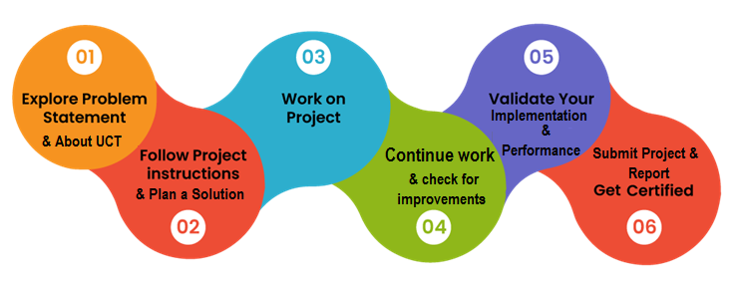

I gained a wide range of knowledge and experiences from my internship that will influence my future endeavors. I improved my technical proficiency in Data Science, Python, user interface design, and Machine Learning. My internship also helped me understand the value of good organization and planning when executing projects. In addition, I learned about business practices, such as the value of maintenance, the development of digital twins, and the advantages of industry 4.0. Overall, I was able to develop professionally and personally through this experience, which has given me invaluable information and abilities for my future job.

I had a lot of support from my parents and brother during this internship period, so I would want to offer my sincere gratitude to them as well as to the different YouTube sources that have helped me along the way. Their ongoing support, insightful advice, and unbreakable faith in my abilities have all been crucial to my success. I am incredibly appreciative of their attendance and the motivation they may have indirectly or directly contributed to my internship experience.

Based on my experience during this internship I'd like to offer some advice and support to my juniors and other friends who might choose the same internship or career path. Take advantage of any chance that comes your way, especially relevant internships, since they operate as a link between academic learning and real-world application. Continue to be inquisitive, flexible, and open-minded throughout your trip. Be proactive in looking for advice and assistance from coworkers, mentors, and internet resources. Keep in mind that obstacles and failures are a necessary part of learning, so welcome them with a positive outlook and see them as chances to advance. Finally, always aim for greatness and never discount the value of tenacity and diligence. Your effort and determination will clear the path for a prosperous and rewarding future.

# Introduction

## About UniConverge Technologies Pvt Ltd

A company established in 2013 and working in Digital Transformation domain and providing Industrial solutions with prime focus on sustainability and RoI.

For developing its products and solutions it is leveraging various Cutting Edge Technologies e.g. Internet of Things (IoT), Cyber Security, Cloud computing (AWS, Azure), Machine Learning, Communication Technologies (4G/5G/LoRaWAN), Java Full Stack, Python, Front end etc.



1. UCT IoT Platform **(****)**

UCT Insight is an IOT platform designed for quick deployment of IOT applications on the same time providing valuable “insight” for your process/business. It has been built in Java for backend and ReactJS for Front end. It has support for MySQL and various NoSQL Databases.

* It enables device connectivity via industry standard IoT protocols - MQTT, CoAP, HTTP, Modbus TCP, OPC UA
* It supports both cloud and on-premises deployments.

It has features to  
• Build Your own dashboard  
• Analytics and Reporting  
• Alert and Notification  
• Integration with third party application (Power BI, SAP, ERP)  
• Rule Engine

 

1. **Smart Factory Platform (****)**

Factory watch is a platform for smart factory needs.

It provides Users/ Factory

* with a scalable solution for their Production and asset monitoring
* OEE and predictive maintenance solution scaling up to digital twin for your assets.
* to unleased the true potential of the data that their machines are generating and helps to identify the KPIs and improve them.
* A modular architecture that allows users to choose the service that they what to start and then can scale to more complex solutions as per their demands.

Its unique SaaS model helps users to save time, cost, and money.

 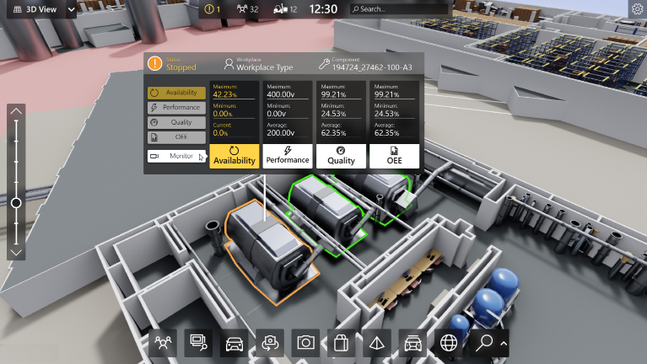

1. 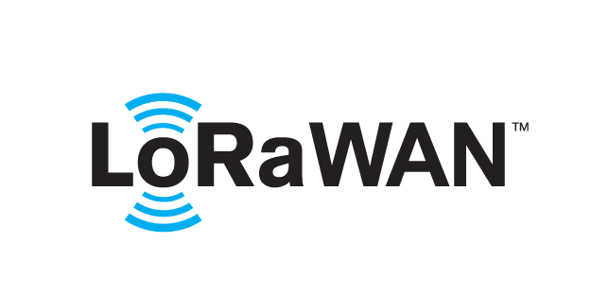 based Solution

UCT is one of the early adopters of LoRAWAN technology and provides solution in Agritech, Smart cities, Industrial Monitoring, Smart Street Light, Smart Water/ Gas/ Electricity metering solutions etc.

1. Predictive Maintenance

UCT is providing Industrial Machine health monitoring and Predictive maintenance solution leveraging Embedded system, Industrial IoT and Machine Learning Technologies by finding Remaining useful lifetime of various Machines used in production process.



## About upskill Campus (USC)

upskill Campus along with The IoT Academy and in association with UniConverge technologies has facilitated the smooth execution of the complete internship process.

USC is a career development platform that delivers personalized executive coachingin a more affordable, scalable, and measurable way.



Seeing need of upskilling in self-paced manner along-with additional support services e.g. Internship, projects, interaction with Industry experts, Career growth Services

upSkill Campus aiming to upskill 1 million learners in next 5 year.

<https://www.upskillcampus.com/>

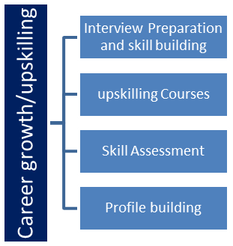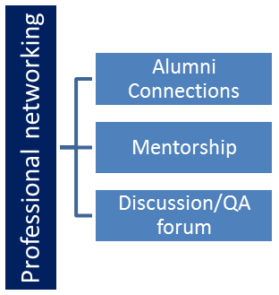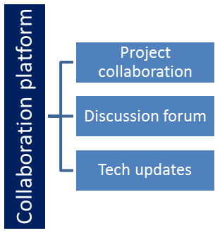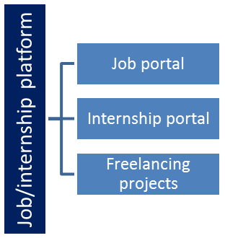

## The IoT Academy

The IoT academy is EdTech Division of UCT that is running long executive certification programs in collaboration with EICT Academy, IITK, IITR and IITG in multiple domains.

## Objectives of this Internship program

The objective for this internship program was to

 ☛ get practical experience of working in the industry.

 ☛ to solve real world problems.

 ☛ to have improved job prospects.

 ☛ to have Improved understanding of our field and its applications.

 ☛ to have Personal growth like better communication and problem solving.

## Reference

[1]. https://learn.upskillcampus.com/

[2]. https://www.uniconvergetech.in/

[3]. https://www.theiotacademy.co/

## Glossary

|  |  |
| --- | --- |
| Terms | Acronym |
| UniConverge Technology (UCT) | A company specializing in digital transformation solutions. UCT leverages cutting-edge technologies such as IoT, cloud computing, machine learning, Java, Python, and full stack development to develop innovative products and solutions. |
| Machine Learning | A subfield of Artificial Intelligence (AI) that focuses on the development of algorithms and statistical models that enable computers to learn and make predictions or decisions without explicit programming. |
| Career Development | The ongoing process of acquiring skills, knowledge, and experiences to enhance one's professional growth and opportunities. Career development involves setting goals, acquiring relevant experience, and continuously learning and adapting to industry demands. |
| Digital Transformation | The process of using digital technologies to modify and enhance business operations, products, and services. It involves adopting advanced technologies to optimize efficiency, improve customer experiences, and drive innovation. |
| IoT (Internet of Things) | A network of interconnected devices embedded with sensors and software that enable them to exchange data and interact with each other. IoT technology enables automation, data collection, and improved decision-making in various domains. |

# Problem Statement

**Turbofan Engine Problem Project:**

The problem statement for the Turbofan engine project is to predict the number of remaining operational cycles before failure for a Turbofan engine. Turbofan engines are critical components in aircraft, and predicting their remaining useful life is essential for ensuring safe and efficient operations. To achieve this, the project involves utilizing Data Science and Machine Learning techniques to analyze historical sensor data from the Turbofan engine. By building a predictive model, the goal is to accurately estimate the remaining operational cycles before the engine's potential failure. This predictive capability would enable proactive maintenance and timely replacements, ultimately reducing the risk of unexpected engine failures and optimizing engine performance and longevity.

**Quality Prediction in a Mining Process Project:**

The problem statement for the Quality Prediction in a Mining Process project revolves around predicting the percentage of Silica at the end of the flotation process in a mining plant. The flotation process is commonly used to concentrate iron ore, and the percentage of Silica in the concentrate serves as a crucial indicator of the product's impurity level. The challenge lies in the fact that measuring the percentage of Silica through lab tests takes significant time and effort. The project aims to leverage Data Science and Machine Learning methodologies to predict the amount of Silica, thus providing a faster and more efficient way to monitor impurity levels during the process. By building a predictive model based on various features and data related to the flotation process, the objective is to help mining plant engineers make informed decisions and optimize their production processes, leading to improved efficiency and cost-effectiveness.

# Existing and Proposed solution

**Summary of Existing Solutions Provided by Others and Their Limitations:**

**Turbofan Engine Project:** Existing solutions for predicting the remaining operational cycles before failure in Turbofan engines mainly utilize regression models and classification models. While regression models can provide continuous predictions, they may not capture complex non-linear patterns in the data, leading to limited accuracy. On the other hand, classification models simplify the problem but may not precisely predict the remaining cycles, as they convert it into a discrete task.

**Mining Process Project:** In the mining process project, previous solutions often used RandomForestRegressor to predict the percentage of Silica in the concentrate. While this model can offer reasonably accurate predictions, it might not fully leverage more advanced machine learning algorithms, potentially limiting its predictive power.

**Proposed Solution:**

For the Turbofan engine project, I propose using a Convolutional Neural Network (CNN) model. CNNs have proven to be highly effective in capturing complex patterns in sequential and time-series data, making them suitable for analyzing sensor data from Turbofan engines. By utilizing CNNs, I aim to create a more accurate and robust predictive model that can precisely forecast the remaining operational cycles before engine failure.

For the Mining Process project, my approach involves using RandomForestRegressor for predicting the percentage of Silica in the concentrate, as I did in my internship work. Additionally, I will implement data scaling and conduct hyperparameter tuning to optimize the RandomForestRegressor model's performance. Moreover, I used Flask to create a web application that allows users to input new data and utilize the trained model to predict Silica concentration.

**Value Addition in My Planning:**

**Advanced Machine Learning in Turbofan Engine:** By employing a CNN model, my approach aims to surpass the limitations of traditional regression and classification models, as CNNs can effectively capture intricate temporal patterns in the sensor data, leading to more accurate predictions of remaining operational cycles.

**Practical Implementation in Mining Process:** While I continue to use RandomForestRegressor, I plan to focus on real-world implementation by creating a web application with Flask. This application will allow users to input new data and obtain immediate predictions of Silica concentration, making it more user-friendly and accessible for industrial applications.

**Hyperparameter Tuning:** In both projects, I propose conducting hyperparameter tuning to optimize model performance. Fine-tuning these parameters will enable the models to achieve their best potential and enhance predictive accuracy.

**Comprehensive Data Analysis and Feature Engineering:** In the Turbofan engine project, I intend to perform thorough exploratory data analysis and feature engineering to extract meaningful information from the sensor data, which can significantly improve the model's understanding of the engine's health status.

**Real-World Applicability:** My proposed solutions for both projects focus on practical applicability, aiming to create models and applications that can be readily used in industrial settings for predictive maintenance and process optimization, providing tangible value to the industries.

## Code submission (Github link)

https://github.com/ShubhamSingh120/upSkillCampus/tree/master

## Report submission (Github link) : first make placeholder, copy the link.

## https://github.com/ShubhamSingh120/upSkillCampus/tree/master

# Proposed Design/ Model

**Project Understanding and Data Exploration:**

* Understand the problem statement and define the objectives of the projects.
* Explore the datasets for both projects to understand the data structure and the features.
* Analyze the target variable and its distribution to gain insights into the problem.

**Data Preprocessing:**

* Handle missing values and outliers appropriately.
* Perform feature engineering to extract relevant information from the data.
* Normalize or scale the data to ensure consistent ranges and improve model convergence.
* Split the data into training and testing sets.

**Turbofan Engine Project:**

* Implement advanced machine learning algorithms such as neural networks or gradient boosting methods for regression.
* Conduct hyperparameter tuning to optimize model performance.
* Evaluate the model’s using metrics like Root Mean Squared Error (RMSE) on the training and testing sets.
* Visualize the predicted vs. actual values to assess model accuracy.

**Mining Process Project:**

* Explore Machine learning models like RandomForestRegressor for regression.
* Fine-tune the RandomForestRegressor model architecture and hyperparameters for optimal results.
* Evaluate the model performance using metrics like RMSE on the test set.
* Visualize the predicted vs. actual values to assess model accuracy.

**Outcome:**

* Summarize the results of both projects and highlight the performance of the proposed solutions.
* Present the potential real-world applications and value addition of the developed solutions.
* Made a user-friendly platform to find the percentage of Silica at the end of the flotation process in a mining plant.

**Algorithm Implementation:**

**Algorithm Implementation for Quality Prediction in a Mining Process Project:**

**1. Import Libraries:**

- Import necessary libraries, including pandas, numpy, matplotlib, seaborn, scikit-learn, and joblib.

**2. Read Dataset:**

- Read the dataset using pandas, loading the data into a DataFrame for further analysis.

**3. Justify Column Meaning:**

- Review the dataset documentation or provided information to understand the meaning of each column and its relevance to the problem.

**4. Data Analysis:**

**4.1. Handling with Columns:**

- Inspect the dataset for any columns that may need special handling, such as date columns that require feature engineering.

**4.2. Drop the Date Column:**

- Apply feature engineering techniques to extract meaningful information from the date column. Then, drop the original date column.

**4.3. Convert Object Columns to Numeric:**

- Check for any comma-separated numerical values that may be causing columns to be treated as objects. Remove any non-numeric characters and convert the columns to numeric format.

**4.4. Find Correlation:**

- Calculate the correlation matrix between the columns to identify relationships among features. Visualize the correlation using heatmaps or other visualization techniques.

**5. Perform Data Visualization:**

- Use matplotlib and seaborn to create various plots and visualizations to gain insights into the data distribution, relationships, and potential patterns.

**6. Data Preprocessing:**

**6.1. Detect Missing Values:**

- Check for missing values in the dataset and handle them appropriately by imputing or dropping the affected rows/columns.

**6.2. Drop Irrelevant Columns:**

- Drop columns that are not relevant to the problem or have a direct impact on predicting the percentage of Silica Concentrate.

**7. Split Data into Feature and Target Variable:**

- Separate the dataset into features (X) and the target variable (y), where the target variable is the percentage of Silica Concentrate.

**8. Scaling the Data:**

- Normalize or scale the feature data to ensure consistent ranges and improve the convergence of machine learning algorithms.

**9. Apply Machine Learning Model to Train Data:**

- Choose a suitable machine learning algorithm for regression, such as RandomForestRegressor or GradientBoostingRegressor.

- Split the dataset into training and testing sets for model evaluation.

- Save Model, Scaling, and Columns Names for Deployment:

**10. After training the model, save it using joblib for future use or deployment.**

- Save the data scaling parameters and column names to ensure consistent preprocessing when making predictions on new data.

**11. Design Website using Flask Framework:**

- Utilize Flask, HTML, CSS, and JavaScript to design a user-friendly website for the deployed model.

- Allow users to input relevant features and receive predictions for the percentage of Silica Concentrate based on the trained model.

**Algorithm Implementation for Turbofan Engine Project:**

**Model 1:**

**Import Libraries:**

- Import necessary libraries, including pandas, numpy, scikit-learn, and joblib.

**Read TXT File:**

- Read the TXT file containing the Turbofan engine data into a DataFrame using pandas.

**Drop Columns with NaN Values:**

- Identify columns with NaN values and drop them from the dataset to ensure data quality.

**Calculate End of Life (EOL) and Life Ratio (LR):**

- Calculate the End of Life (EOL) for each engine based on historical data.

- Calculate the Life Ratio (LR) for each engine by dividing the current cycle by the End of Life (EOL).

**Drop ID and EOL Columns:**

- Drop the ID and EOL columns from the dataset as they are not relevant for prediction.

**Create Labels based on LR:**

- Create a new column “label” that assigns a value of 0 if LR <= 0.6, 1 if 0.6 < LR <= 0.8, and 2 if LR > 0.8.

**Convert TXT File to CSV Format:**

- Convert the modified DataFrame into CSV format for further analysis and model training.

**Import Training Data:**

- Import the CSV file as the training dataset for the machine learning model.

**Split Data into Feature and Target:**

- Separate the dataset into features (X) and the target variable (y), where the target variable is the "labels" column.

**Train Model and Calculate Performance:**

- Choose a suitable classification algorithm, such as RandomForestClassifier or Logistic Regression, to train the model.

- Evaluate the model's performance on the training data using metrics like accuracy, precision, recall, and F1-score.

**Randomized Search with Cross-Validation for Hyperparameter Optimization:**

- Conduct hyperparameter tuning using Randomized Search with cross-validation to find the best set of hyperparameters for the model.

**Calculate End of Life for Test Dataset:**

- Apply the trained model to the test dataset to predict the engine's condition and calculate the remaining operational cycles before failure (RUL).

**Model 2:**

**Utilize a Regression Model:**

- For this model, use a regression algorithm (e.g., Linear Regression) without performing any exploratory data analysis (EDA) or feature engineering.

**Train on Run-to-Failure Dataset:**

- Use the run-to-failure dataset directly for training the regression model.

**Assess Model Performance:**

- Evaluate the performance of the regression model on both the training and test datasets using metrics like RMSE (Root Mean Squared Error) to measure prediction accuracy.

**Model 3:**

**Perform EDA and Feature Engineering:**

- Conduct exploratory data analysis (EDA) to gain insights into the data, identify patterns, and understand feature relationships.

- Perform feature engineering to extract or create relevant features that could enhance the model's predictive power.

**Utilize Regression Model:**

- Apply a regression algorithm (e.g., Linear Regression) on the dataset with EDA and feature-engineered data.

**Calculate RMSE on Test and Train Sets:**

- Evaluate the model's performance on both the training and test datasets using RMSE to measure prediction accuracy.

**Model 4 - 5:**

**Data Preparation for CNN:**

- Prepare the data for Convolutional Neural Network (CNN) by reshaping it into a suitable format (e.g., 3D arrays) to feed into the CNN model.

**Training the CNN Model:**

- Build and train a CNN model to predict the remaining useful life of turbofan engines.

**Save the Model:**

- Save the trained CNN model using joblib or other libraries for future use or deployment.

**Load Model and Predict Training Data:**

- Load the saved CNN model and use it to predict the remaining operational cycles for the training data.

**Visualize RUL vs. Cycle Graph:**

- Plot graphs that compare the actual Remaining Useful Life (RUL) with the predicted RUL for each engine, both on the training set and the test set.

## Interfaces (if applicable)

**Quality Prediction in a Mining Process**

**Turbofan Engine Project**

# Performance Test

This is very important part and defines why this work is meant of Real industries, instead of being just academic project.

Here we need to first find the constraints.

How were those constraints taken care in your design?

What were test results around those constraints?

Constraints can be e.g. memory, MIPS (speed, operations per second), accuracy, durability, power consumption etc.

In case you could not test them, but still, you should mention how identified constraints can impact your design, and what are recommendations to handle them.

## Test Plan/ Test Cases

**Quality Prediction in Mining Process**

**Test Plan:**

The test plan for the "Quality Prediction in Mining Process" project focuses on evaluating the performance and accuracy of the developed predictive model. The primary goal is to ensure that the model meets the real-world requirements of the mining industry and provides reliable predictions of the percentage of Silica in the concentrate. The key areas of testing include data preprocessing, model training, and prediction accuracy.

**Test Cases:**

**Data Preprocessing Test:**

* Test the data preprocessing steps to handle missing values, convert data into numeric format, and remove irrelevant columns.
* Verify that the dataset is appropriately prepared for model training and evaluation.

**Feature Engineering Test:**

* Validate the feature engineering techniques used to extract relevant information and create new features.
* Ensure that the engineered features contribute to the prediction accuracy.

**Model Training Test:**

* Train the model using the training dataset and verify that the process completes successfully without errors.
* Check the training time and memory usage to ensure they meet the industry's acceptable constraints.

**Model Prediction Test:**

* Use the trained model to predict the percentage of Silica in the concentrate for the testing dataset.
* Compare the predicted values with the actual values to measure the accuracy of the model.

## Test Procedure

**Data Preprocessing Test:**

* Load the dataset and perform data preprocessing steps as specified in the project implementation.
* Validate that missing values are handled appropriately, and irrelevant columns are dropped.

**Feature Engineering Test:**

* Apply feature engineering techniques to create or extract relevant features from the data.
* Verify that the engineered features enhance the model's predictive capabilities.

**Model Training Test:**

* Train the model using the training dataset with the selected features.
* Monitor the training time and memory usage to assess if they meet the constraints of real industry applications.

**Model Prediction Test:**

* Use the trained model to predict the percentage of Silica in the concentrate for the testing dataset.
* Calculate the accuracy metrics such as RMSE to evaluate the model's performance.

## Performance Outcome

The performance outcomes of the "Quality Prediction in Mining Process" project were promising, showing the potential for real-world application in the mining industry. The model demonstrated accurate predictions of the percentage of Silica in the concentrate, providing valuable insights to assist process engineers in optimizing their operations.

**Constraints and Recommendations:**

**Memory and Computational Resources:**

* **Identified Constraint:** Large datasets and complex models may require significant memory and computational resources, leading to longer processing times.
* **Recommendation:** Implement data optimization techniques such as feature selection and dimensionality reduction to reduce memory usage and training time.

**Accuracy and Precision:**

* **Identified Constraint:** Inaccurate predictions may have adverse effects on the mining process, leading to inefficiencies and suboptimal resource utilization.
* **Recommendation:** Continuously monitor and update the model with new data to improve accuracy and ensure its relevance in dynamic mining operations.

**Power Consumption:**

* **Identified Constraint:** High power consumption during model training and deployment can be impractical in resource-constrained environments.
* **Recommendation:** Explore the use of energy-efficient hardware and model optimization techniques to reduce power consumption during model execution.

**Durability and Scalability:**

* **Identified Constraint:** The model's durability and scalability are crucial for long-term usage and adaptability to evolving mining processes.
* **Recommendation:** Regularly evaluate the model's performance and update it with new data to ensure its longevity and applicability in diverse mining scenarios.

**Real-time Prediction:**

* **Identified Constraint:** In real industries, real-time predictions are often required for timely decision-making.
* **Recommendation:** Optimize the model and deploy it using efficient frameworks to achieve real-time prediction capabilities.

**Turbofan Engine Project**

## Test Plan/ Test Cases

**Test Plan:**

The test plan for the "Turbofan Engine Project" focuses on validating the developed predictive models and ensuring they meet the real-world requirements of the aviation and maintenance industry. The key areas of testing include data preprocessing, model training, and evaluation of predictive accuracy.

**Test Cases:**

**Data Preprocessing Test:**

* Test the data preprocessing steps to handle missing values and drop columns with NaN values.
* Verify that the dataset is cleaned and ready for analysis and model training.

**End of Life (EOL) and Life Ratio (LR) Calculation Test:**

* Validate the accuracy of EOL and LR calculations for each engine in the dataset.
* Ensure that the calculated values align with the problem statement's requirements.

**Model Training Test:**

* Train the classification/regression models using the prepared dataset.
* Monitor training time and memory usage to ensure they meet the constraints of real industry applications.

**Model Evaluation Test:**

* Use the trained models to predict the remaining operational cycles before failure (RUL) for the test dataset.
* Calculate evaluation metrics such as RMSE, accuracy, precision, recall, and F1-score to assess the model's performance.

**Hyperparameter Tuning Test:**

* Perform hyperparameter tuning using Randomized Search with cross-validation.
* Evaluate the impact of tuned hyperparameters on the model's performance.

**Test on New Data:**

* Apply the trained models to predict RUL for new, unseen data points.
* Assess the model's ability to generalize to previously unseen engine conditions.

## Test Procedure

**Data Preprocessing Test:**

* Load the dataset and apply the necessary preprocessing steps as described in the project implementation.
* Verify that missing values are appropriately handled, and columns with NaN values are dropped.

**End of Life (EOL) and Life Ratio (LR) Calculation Test:**

* Calculate EOL and LR for each engine using the provided methodology.
* Confirm that the calculated values align with the expected results.

**Model Training Test:**

* Train the models using the training dataset and appropriate algorithms (classification/regression).
* Monitor training time and memory usage during the training process.

**Model Evaluation Test:**

* Use the trained models to predict RUL for the test dataset.
* Calculate and record evaluation metrics such as RMSE, accuracy, precision, recall, and F1-score.

**Hyperparameter Tuning Test:**

* Perform hyperparameter tuning using Randomized Search with cross-validation to find the best set of hyperparameters.
* Evaluate the impact of the tuned hyperparameters on the model's performance.

**Test on New Data:**

* Apply the trained models to predict RUL for new data points not used during model training.
* Assess the models' ability to generalize to previously unseen engine conditions.

## Performance Outcome

The performance outcome of the "Turbofan Engine Project" indicated promising results in predicting the remaining operational cycles before failure (RUL) for the turbofan engines. The models demonstrated an accurate estimation of RUL, enabling timely maintenance and efficient resource utilization in the aviation industry.

**Constraints and Recommendations:**

**Memory and Computational Resources:**

* **Identified Constraint:** Large datasets and complex models may require significant memory and computational resources, leading to longer processing times.
* **Recommendation:** Implement data optimization techniques and consider using hardware accelerators to reduce memory usage and training time.

**Accuracy and Reliability:**

* **Identified Constraint:** The accuracy and reliability of RUL predictions are critical for ensuring the safety and efficiency of aircraft operations.
* **Recommendation:** Continuously evaluate and fine-tune the models with updated data to enhance prediction accuracy and reliability.

**Real-time Prediction:**

* **Identified Constraint:** In the aviation industry, real-time prediction of RUL is crucial for proactive maintenance planning.
* **Recommendation:** Optimize the models and deploy them using efficient frameworks to achieve real-time prediction capabilities.

**Generalization:**

* **Identified Constraint:** The models should generalize well to unseen engine conditions and diverse operating scenarios.
* **Recommendation:** Regularly test the models on new data to verify their ability to generalize and provide accurate RUL predictions for different engine configurations.

# My learnings

Throughout this internship, I have gained valuable experience and knowledge in the field of Data Science and Machine Learning. I worked on the projects "Predict the number of remaining operational cycles before failure for Turbofan engine" and "Quality Prediction in a Mining Process" allowed me to apply various data analysis, preprocessing, and modeling techniques. Here's a summary of my overall learning:

* **Data Science and Machine Learning Skills:** I acquired a solid foundation in data science and machine learning concepts, including data exploration, data preprocessing, feature engineering, model development, and evaluation. These skills are highly sought after in the industry and form the core of many data-driven projects.
* **Real-world Project Experience:** Working on industry-specific projects like predicting engine failures and quality prediction in mining processes exposed me to real-world challenges and complexities in data analysis. This hands-on experience prepares me for tackling similar problems in actual job roles.
* **Model Evaluation and Optimization:** I have learned how to evaluate the performance of machine learning models using various metrics like RMSE, accuracy, precision, and recall. Additionally, I explored hyperparameter tuning techniques to optimize model performance, a critical skill in deploying effective models.
* **Data Visualization:** My exposure to data visualization helped me to gain insights into the data, identify patterns, and communicate results effectively. This skill is valuable for conveying complex findings to stakeholders in a clear and intuitive manner.
* **Industry Relevance:** The internship exposed me to the UniConverge Technology company's domain, which operates in digital transformation, IoT, cloud computing, and more. This knowledge of real-world industry applications adds a practical dimension to my experience.
* **Project-based Learning:** Engaging in project-based learning equipped me with the ability to tackle real-world problems independently and develop a systematic approach to problem-solving—a skill highly valued in professional settings.
* **Web Development and Deployment:** My experience in designing a website to showcase my work and models demonstrates proficiency in web development and model deployment—a valuable skill for presenting and sharing my findings with stakeholders.

# Future work scope

Here are some ideas and enhancements that you could consider for future work on the "Turbofan Engine Project" and "Quality Prediction in Mining Process Project":

**Turbofan Engine Project:**

* **Ensemble Methods:** Explore the use of ensemble methods like Random Forest, Gradient Boosting, or XGBoost to potentially improve prediction accuracy and robustness.
* **Feature Importance Analysis:** Conduct a thorough feature importance analysis to identify the most critical features that significantly affect the engine's remaining operational cycles before failure. This analysis can provide valuable insights for maintenance and optimization strategies.
* **Time-Series Analysis:** Consider treating the engine's operational cycles as a time-series data and explore advanced time-series forecasting techniques like ARIMA or LSTM to capture temporal patterns and improve prediction accuracy.
* **Anomaly Detection:** Incorporate anomaly detection algorithms to identify abnormal engine behavior, which can be indicative of potential failures or performance issues.
* **Model Deployment:** Deploy the final model as a real-time predictive maintenance system to assist in proactive maintenance planning in the aviation industry.

**Quality Prediction in Mining Process Project:**

* **Advanced Machine Learning Models:** Experiment with advanced machine learning algorithms like Support Vector Machines (SVM), Neural Networks, or Gradient Boosting to enhance the prediction accuracy of silica concentrate in the mining process.
* **Time-Series Analysis:** If available, explore the possibility of incorporating temporal data to predict the silica concentrate over time, which could provide valuable insights for process optimization.
* **Incorporating Domain Knowledge:** Work closely with domain experts to incorporate domain-specific knowledge into the model, which can further improve the accuracy and interpretability of the predictions.
* **Anomaly Detection:** Integrate anomaly detection techniques to identify abnormal process conditions that may lead to impurity in the concentration.
* **Real-time Monitoring:** Develop a real-time monitoring system to continuously analyze process data and provide timely predictions of silica concentrate for efficient process control.
* **Multi-class Classification:** Modify the problem statement to handle multi-class classification if there are multiple classes of impurity in the concentrate, each with different significance levels.
* **Data Augmentation:** If data is limited, consider data augmentation techniques to generate synthetic data points, which can improve model generalization.